**Assignment #4: *Portraits in Food & Found Objects***

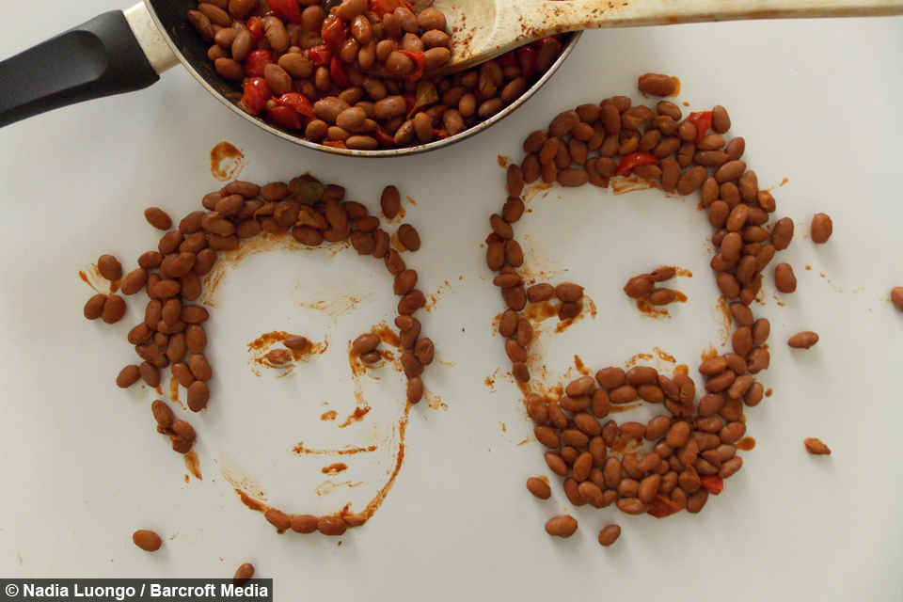

This week I have a bit of a whacky assignment for you. You are going to *create a portrait* using a different kind of material, **food** or **found objects**.

**BE MINDFUL about your materials***.* This is not a time to be wasteful. Create your food portrait on a **clean surface** so that after you snap your photo, you can have yourself a little snack! If food is not an option for you, please try using objects found around the house.

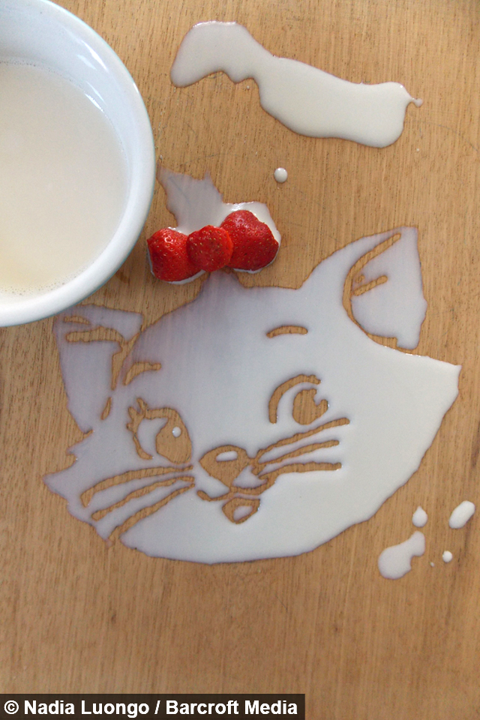

**Supplies you’ll need:**

* **FOOD** *(sauces, snacks, candy, cereal, fruits, bread, etc.)*
* **FOUND OBJECTS** (legos, jewelry, knick-knacks, small toys, pencils, puzzle pieces, items from nature, any other small objects)
* 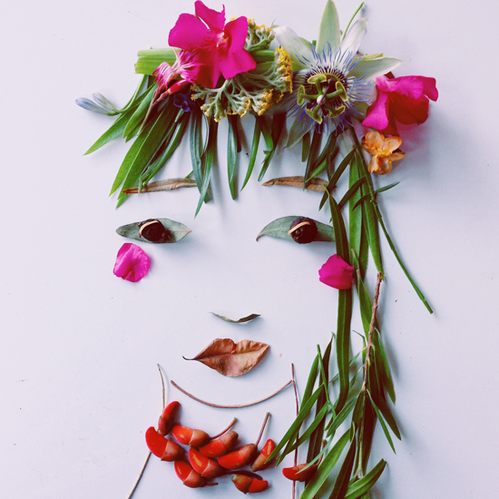**CLEAN SURFACE**

*Nadia Luongo (above)*

*Justina Blakeney (right)*

**REQUIREMENTS:**

* You will create a portrait using a non-conventional material.
* Your artwork should take **at least ONE HOUR** to create. It is very clear to me when something took 5 minutes vs. 60 minutes.
* Reflection – You need to answer the reflection questions and send along with your photo.

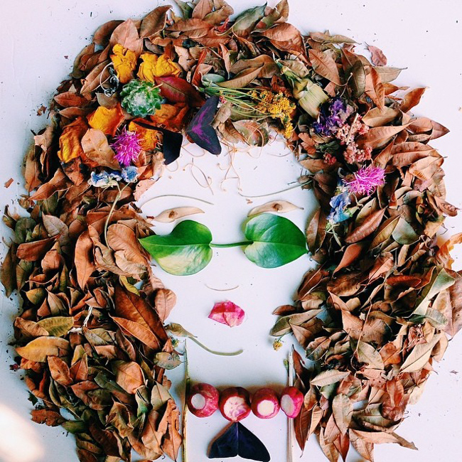*NOTE:* Failure to meet these requirements will result in points taken off.

**VOCABULARY** –

*PORTRAIT* – A drawing, painting, sculpture, or photograph of a person or character, typically from the shoulders up.

*FOUND OBJECT ART* - *Art* created from *objects* or products that are not normally considered art materials.

**Step 1: CHOOSE YOUR SUBJECT MATTER –** *Who will your portrait be of?*

* Someone famous- A celebrity? A musician? A character?
* Cartoon Character?
* Will you create this person?

**Step 2: CHOOSE YOUR MATERIAL-** *What will you use to create your portrait?*

* **What do you have on hand?**
* Look around the house for little items or toys. Legos, paper clips, etc.
* If you want to use food, be mindful not to waste. Crackers, Skittles, etc.
* Take a walk outside and look for rocks, leaves, flowers, etc.

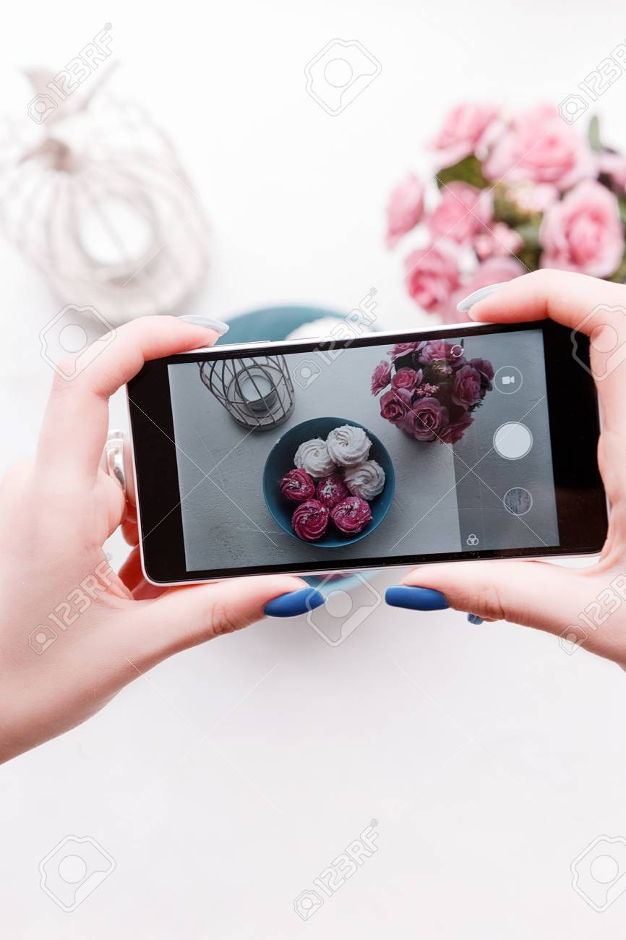**Step 3: CREATE YOUR ARTWORK**

* Build on a clean surface. Somewhere your project won’t get destroyed.
* Play around with positioning of items.
* When you’re finished, snap a clear photo from directly above the portrait.

**Step 4:** **REFLECT** – *Answer the following questions in paragraph or bullet.*

* Who did you choose to create? Why did you choose the materials you did?
* What do you like about your final artwork? Did you surprise yourself?
* What would you change about your artwork?
* How did you feel about this assignment? Like or dislike? Why or why not?

**Step 5: SUBMIT WORK -** *Please send a picture of your artwork AND your reflection.*

How can you send your work? 1 of 3 ways.

1. Send through Office 365 TEAMS (each of you have an account and are already added to your class TEAM)
2. Send through the Remind app
3. Email to me at [cswiatek@nfschools.net](mailto:cswiatek@nfschools.net)

**DUE THURSDAY MAY 7th**

Check out some of the amazing artist’s and examples below for ideas!

Please contact me if you need help.

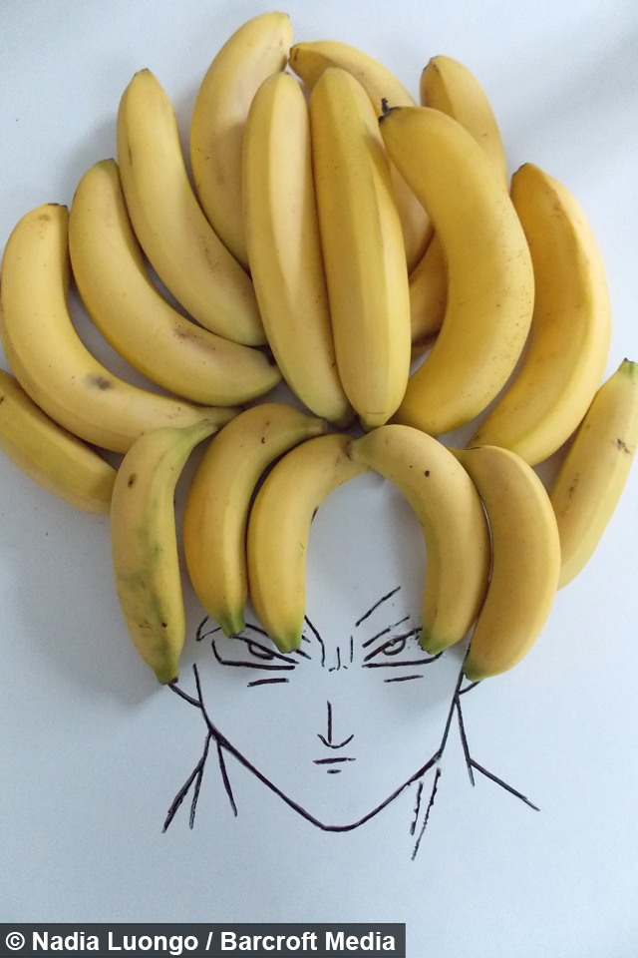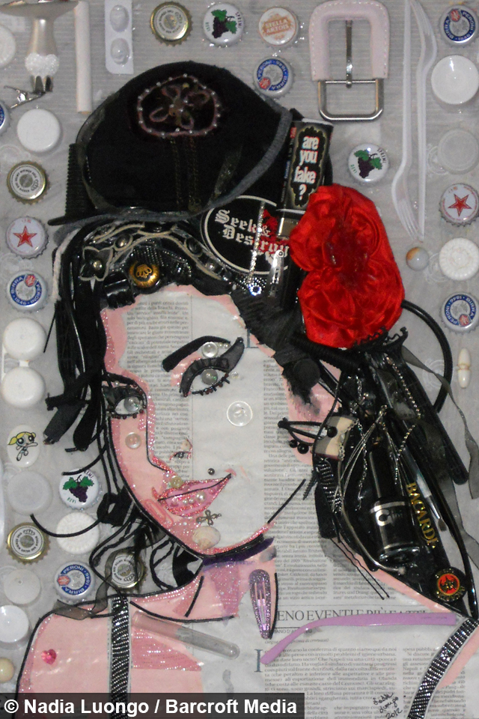**Examples:**

***Nadia Luongo*** *–*

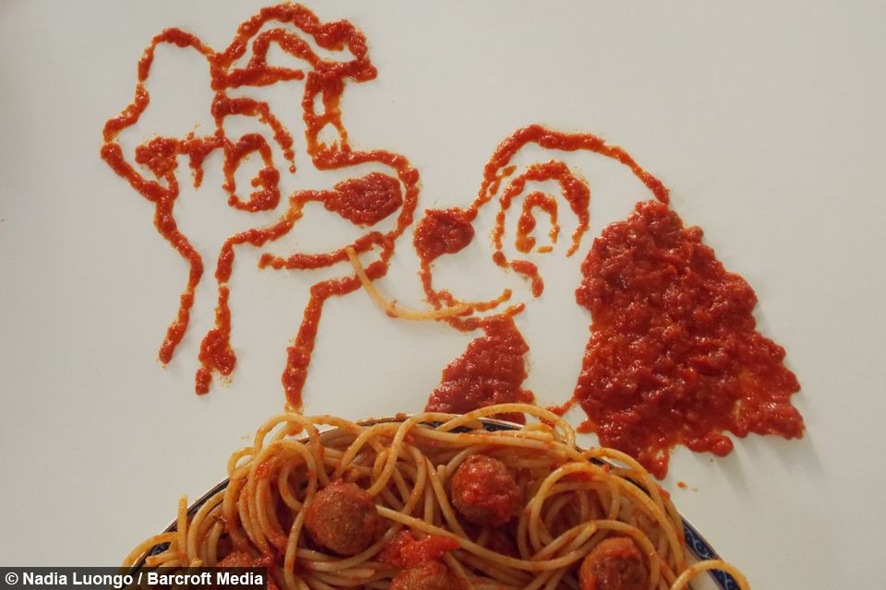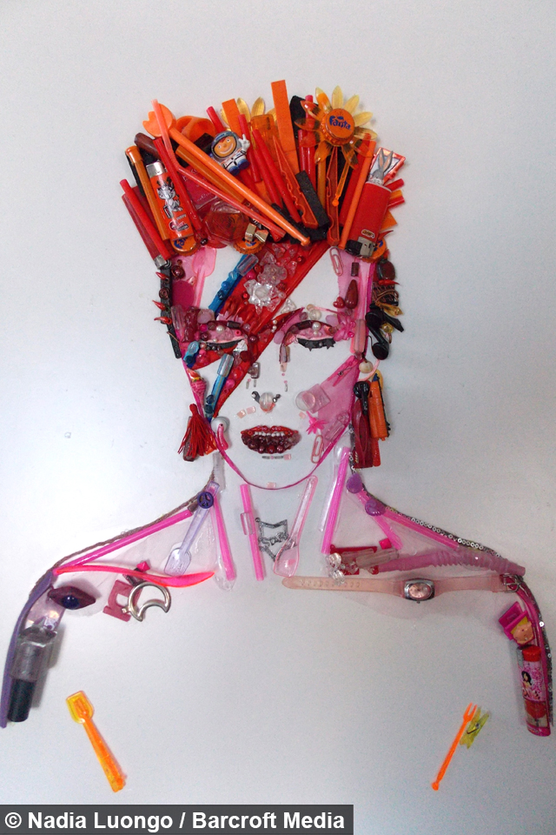*@nadialuongo*

***Justina Blakeney*** *- @FacetheFoliage*

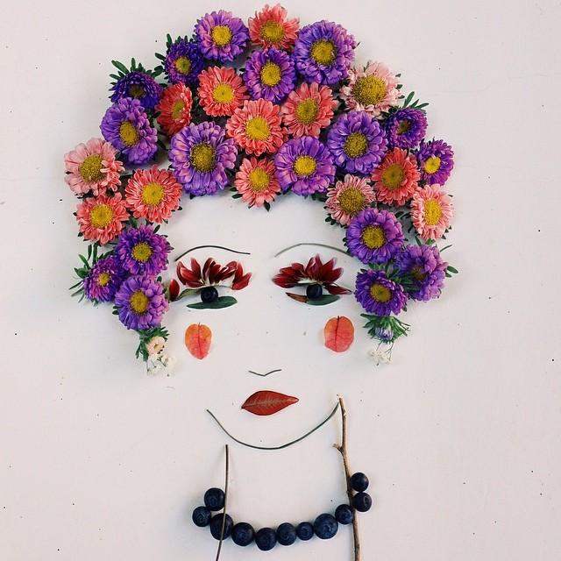 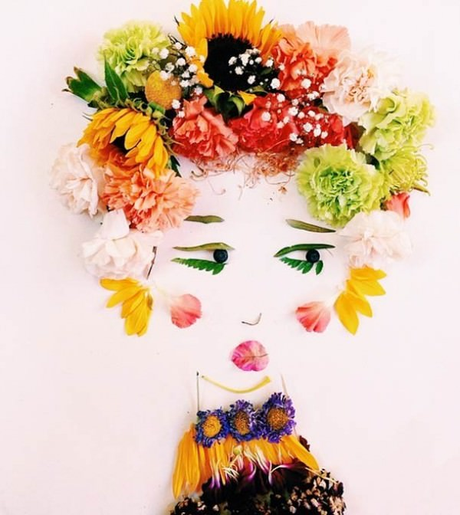 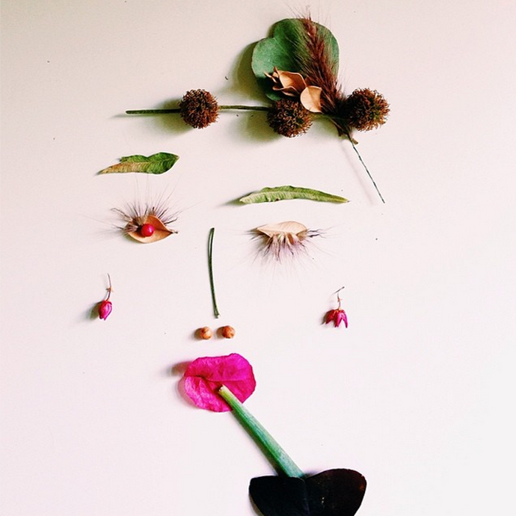

***Laleh Mohmedi*** *- @jacobs_food_diaries*

